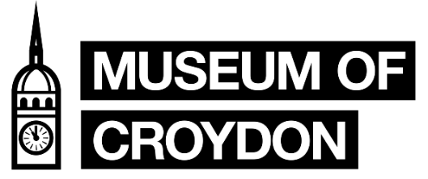
COLLECTIONS VOLUNTEER - (Decant and Collections Care project)
Role Description
The Croydon Council collections are split into four main groups: the Borough Archives, Local Studies, Museum and Handling Collection. Additionally, to this we have an outreach public programme and two temporary exhibition spaces. This collection volunteer role will be working directly with the Museum collection.
The Museum collection consists of the Borough Art Collection of over 2,500 artworks, social history objects, over 500 oral histories, Bronze Age, Roman, Anglo-Saxon objects to over 200 items from the Riesco Collection of Chinese ceramics. From textiles, our Trojan Bubble car to an almost complete Anglo-Saxon skeleton – the collection is diverse in material and stories.
This volunteer role will be working directly back of house, with the Collections Officer. The project will focus on decant of permanent galleries and return of long-term loans. This includes improvement of stored areas for collections.
Tasks Involved
- Object handling.
- Packing objects for storage and/or transport, as required.
- Research on objects, to improve our knowledge of the collection.
- Facilitating and improving accessibility of objects.
- Developing, improving, and updating collection databases (including location control)
- Working with staff and other volunteers.
- Photography of the objects to improve accessibility.
- Promoting the Museum’s services and events to visitors as required.
Skills
- Excellent communication skills and attention to detail
- Friendly and approachable attitude.
- Good organisation and ability to complete tasks independently and within a team.
- Experience of Microsoft Office, including Microsoft Excel.
- An interest in museums and working with historical collections.
- Desirable: to have object handling and/or collection management knowledge.

This role ideally suits, but is not restricted to, individuals with an interest in a career in museums, collection management, collection care or related field. The role can be expanded to be part of a university work placement.

Time Commitment and Access
Ideally you would be able to commit to one day a week Monday to Friday 10.30 to 5pm for minimum of three months. Please be aware that this role will require lifting of object boxes and access to museum storage areas that are only accessible via steps.
Support and Training
- Full induction and relevant training.
- Ongoing support through Volunteer Co-ordinator and Collections Access Officer.

How to Apply
We invite anyone interested in this role to apply via Better Impact as a ‘Museum of Croydon – Collections Volunteer’, please follow link here to Better Impact. We also accept a C.V. and a brief cover note on what interests you in the role via email. If you have any questions in regard to this role, please email museum@croydon.gov.uk.

Please note: Applicants from some overseas countries are required to have a relevant work permit or student visa in order to volunteer in the U.K. By applying you are confirming you have the correct documentation that permits you to volunteer at the Museum of Croydon. Please note this may have to be shown prior to start.

